Welcome to our practice!

PATIENT INFORMATION:

Name: __________________________________________________ Nickname: __________________ Date of birth: ______________ Sex: M____F____

Email: _______________________________________________________ SSN: _______-_______-_________ Driver’s license: _______________________

Address:______________________________________________________________Apt:______City:__________________State:______Zip:___________

Home phone: ___________________________ Cell phone: ___________________________

For appointment reminders: Email:_____Text message:_____ (please select one)

Employer: ______________________________________________ Work phone___________________________

Address:_______________________________________________________________________City:__________________State:______Zip:___________

Emergency contact: Name: ________________________________________Phone: _____________________ Relationship to patient: ______________

Marital status: Single____ Married ____ Divorced ____ Separated ____ Widowed____

Spouse’s name: ________________________________________________Spouse’s employer: ______________ Work phone: _____________________

Address (if different than above): _________________________________________ Apt:______City:__________________State:______Zip:____________

How did you hear about our office? Beaverton Resource Guide____Internet search____ Insurance company____Our website____

Patient referral ____ Zoc Doc ____Other (please specify) ________________________________________________________________

If you were referred by a patient, who may we thank? ___________________________________________________________________

PRIMARY INSURANCE INFORMATION:

Policy holder name: __________________________________________ Member’s ID# or SSN__________________________ Date of birth:___________

Policy holder address: __________________________________________________________________________________________________________

Group name/Policy holder employer name: __________________________________________Group # or Policy #_______________________________

Insurance company name: ________________________________________________________Phone #: _______________________________________

Claims address: _______________________________________________________City: __________________________State: _____ Zip: ___________

SECONDARY INSURANCE INFORMATION:

Policy holder name: __________________________________________ Member’s ID# or SSN__________________________ Date of birth:___________

Policy holder address: __________________________________________________________________________________________________________

Group name/Policy holder employer name: __________________________________________Group # or Policy #_______________________________

Insurance company name: ________________________________________________________Phone #: _______________________________________

Claims address: _______________________________________________________City: __________________________State: _____ Zip: ___________

Regarding Insurance:

We file insurance claims for all patients with insurance benefits. We accept assignment of insurance benefits, however the balance is your responsibility whether your insurance company pays or not. We cannot bill your insurance company unless you give us your complete insurance information. Your insurance policy is a contract between you and your insurance company. We are not a party to that contract. If your insurance company has not paid on your claim within 45 days, the full balance will automatically be transferred to you. That balance will be due upon billing.

We appreciate your payment upon receipt of services. In the event that your insurance company denies payment of a service, you are responsible for that fee. Any unpaid balance after insurance pays is due within 45 (forty-five) days.
Patient Consent:

I hereby authorize Preferred Dental Care Center to take the necessary x-rays, study models, photographs or any other diagnostic aids deemed appropriate to make a thorough diagnosis of the patient’s dental needs. I also authorize Preferred Dental Care Center to perform any and all forms of treatment, medication and therapy that may be indicated. I also understand the use of anesthetic agents embodies a certain risk. I understand that my dental insurance is a contract between the insurance company and me; not between Preferred Dental Care Center and my insurance company. I fully understand that it is my responsibility for all dental treatment regardless of insurance coverage.

I hereby authorize the release of any information to my insurance company or companies, including records of examinations, diagnosis and/or treatment. This release is solely for the purpose of facilitating the billing and reimbursement, directly to Preferred Dental Care Center of insurance benefits under which I am entitled. I agree that I am financially responsible for all treatment rendered, and understand that complete payment will be made after each treatment, unless other financial arrangements have been previously arranged.

Patient signature: ________________________________________________ Date: _______________ Dr. initials:___________

Our Financial Philosophy:

It is important to us that the quality of our business services matches the quality of our dental care. We want the handling of your account to be perceived as an extension of the dental care we provide to you and your family.

Patient’s Role

As with any partnership, both parties have a role to play. Our role is to provide you with quality service. In turn, your role is to pay for your treatment at time of services. Our team will work with you to determine financial arrangements that make sense for both of us. With an agreement made, our joint follow-through will result in a win for everyone. So that we may file your insurance claim(s) correctly, we ask all patients to complete our’ Information’ and ‘Insurance Form’ before seeing the doctor as that insures our office of obtaining the correct information to better serve you in regards to your benefits.

WE ACCEPT CASH, CHECKS, MASTERCARD or VISA. Ask us about our EASY PAY OPTIONS. We offer access to EXTENDED PAYMENT PLANS WITH CREDIT APPROVAL (credit check may apply).

I understand that any unpaid balance after 60 (sixty) days is charged a yearly finance charge of 18%. I further understand that this finance charge is equal to 1.5% of my outstanding balance per month. I understand that if my account reaches collection status (90 days) and I make no effort to pay off my account, my account will be assigned to a collection attorney or agency. If Preferred Dental Care Center must take additional steps to collect on my account, I will be responsible for ALL costs of collection, including court cost and attorney’s fees incurred. I give consent for any credit check to be completed by Preferred Dental Care Center should it be deemed necessary.

Our Cancellation Policy:

If you are unable to meet your appointment, our office requires a 24 hour notification for all cancellations. If you are unable to provide a 24 hour notice, you will be charged $100.00.

I have read the Financial Philosophy and Cancellation Policy. I understand, accept and agree to this Financial Philosophy.

_____________________________________ ______________ ___________________________________ ____________
Signature of patient or responsible party Date Witness for Preferred Dental Care Center Date

.

HIPAA PRIVACY FORM
Acknowledgement of Receipt of Notice of Privacy Practices
Purpose: This form is used to obtain acknowledgement of receipt of our Notice of Privacy Practices or to document our good faith effort to obtain that acknowledgement. **You may refuse to sign this acknowledgement**
I, ____________________________, have received a copy/explanation of this office’s Notice of Privacy Practices.
(Print Name of Patient or guardian)
______________________________ ______________________________ __________________
(Signature of patient and/or guardian) (Relationship to patient/self or other) Date
For Office Use Only

We attempted to obtain written acknowledgement of receipt of our Notice of Privacy Practices, but acknowledgement could not be obtained because:
- Individual refused to sign
- Communications barriers (such as a language barrier) prohibited obtaining the acknowledgment
- An emergency situation prevented us from obtaining acknowledgement at time of service
- Other (Please specify) ___________________________________________________________
DENTAL HEALTH HISTORY:

Name of former dentist: _____________________________________ How long since you were last seen? _____________

1. Have you ever been told by a physician or dentist that you need to be pre-medicated prior to any dental treatment? Y______N_______

2. On a scale of 1-10, 10 being the best, where would you rate your smile? ________ Where would you rate your oral health? _________

3. Have you experienced any of the following problems?

Bleeding gums Y ____N____ Sensitivity to hot and cold Y ____N____
Bad breath or sour taste in mouth Y ____N____ Snoring Y ____N____
Burning sensations in mouth Y ____N____ Food catching between teeth Y ____N____
Soreness in jaw Y ____N____ Clenching or grinding of teeth Y ____N____
Is it hard for you to open wide Y ____N____ Pain/soreness around ears, eyes, face Y ____N____
Clicking or popping in jaw Y ____N____ Stiff neck muscles Y ____N____
Did you ever wear braces Y ____N____ Ever been injured in your mouth or head Y ____N____
Oral surgery of any kind Y ____N____ Do you smoke or chew tobacco Y ____N____

4. Does having dental treatment make you afraid or nervous? Y___N___ if yes, what specific things bother you? ____________________

5. If you could change anything about your smile which of the following would you want? (Please circle all that apply)

Whiter Close space or spaces Replace chipped teeth Replace missing teeth

Remove stains/spots Replace old crowns Remove silver fillings Excess showing of teeth

Straighter Less gum showing Reshape/resize my teeth Replace old plastic filling(s)

Which factors are most important to you when making dental health decisions?
(Please circle all that apply)

Convenience Appearance Relationship with dental team
Finances Time Quality of care
What insurance covers Health Detailed treatment explanations
Fear or anxiety Comfort Technology

Our Standard of Practice:
We are pleased to participate in your dental health care. Our office aims to provide the highest level of preventative care. This includes the following standards of practice for all of our patients as preventative measures. A few of these standards are listed below:

Velscope Test: Oral cancer screening (billed to your insurance - $40.00)

Fluoride Treatment: Prevents tooth decay and strengthens teeth (billed to your insurance - $40.00)

Please note: As a courtesy, we will always bill your insurance for these services. Each insurance policy is different and these services may not be a covered benefit with your plan.

Patient signature:________________________________________________________ Date:___________________

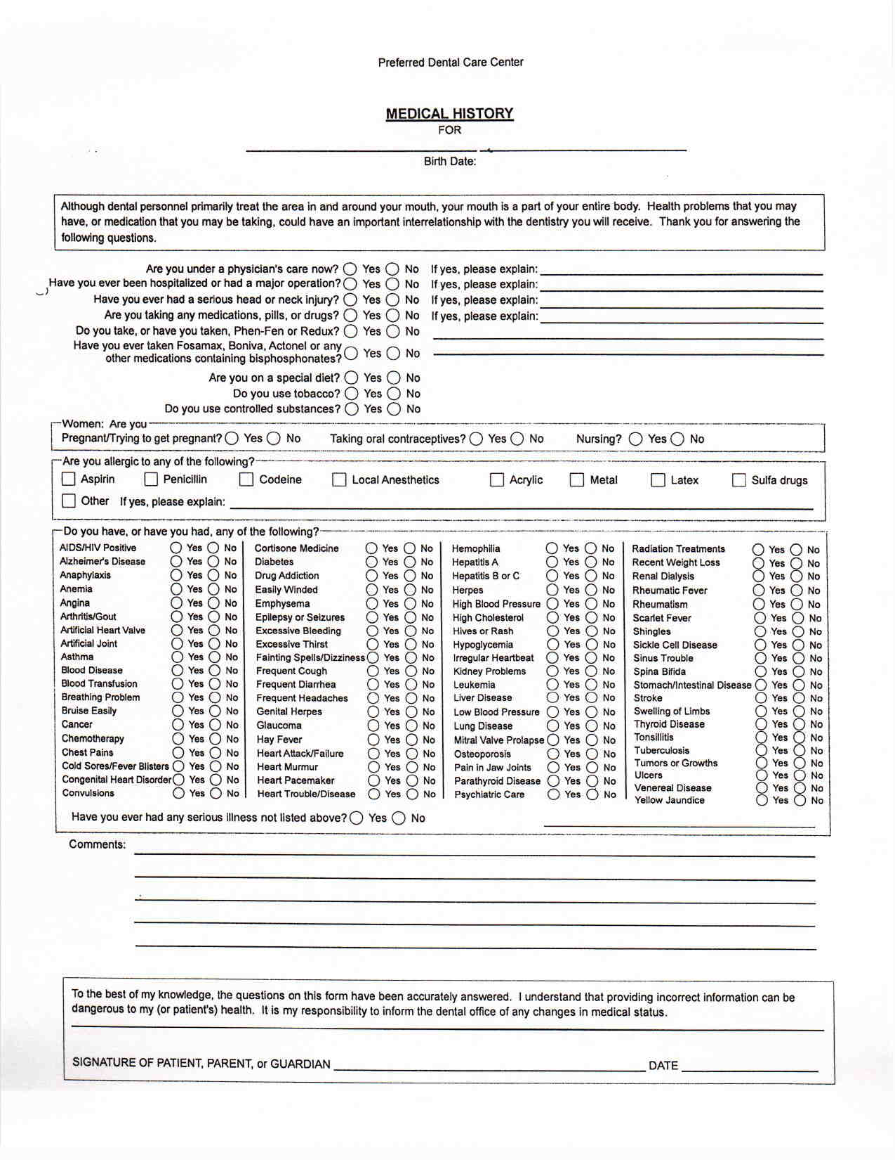

Preferred Dental Care Center
NOTICE OF PRIVACY PRACTICES

These two pages are for you to keep. You do not need to bring them in with you to your first appointment.

THIS NOTICE DESCRIBES HOW MEDICAL INFORMATION ABOUT YOU MAY BE USED AND DISCLOSED AND HOW YOU CAN GET ACCESS TO THIS INFORMATION. PLEASE REVIEW IT CAREFULLY.

If you have any questions about this notice, please contact the designated privacy officer of our office at: (503) 350-1234. 4690 SW Hall Blvd. Beaverton, OR 97005. We take responsibility to safeguard your protected health information very seriously. We value your trust as an important part of our ability to provide you with the best possible medical care. We are dedicated to defending your right to a confidential relationship with your physician.
This notice is intended to inform you of how we protect, use and disclose your information, as well as to explain your right to control these disclosures.

Your Health Information
We may use and disclose health information about you without your permission for the following purposes:

- We may disclose your information for treatment purposes and to coordinate your medical care.
- We may disclose your information to ensure that you receive insurance benefits.
- We may disclose your information internally to enhance the operation of our practice. This includes our commitment to reviewing the quality of care we provide.
- We may disclose your information to comply with a limited number of legal requirements, as outlined in this notice.
Additional information regarding each of these disclosures is provided in this notice. In any case, we will only disclose the minimum amount of information necessary for the purpose it was requested.
Effective Date: March 23, 2013

Our Duties
We are required by law to keep your information private. We must also provide you with this Notice and abide by its terms. We may need to revise our privacy practices from time to time. We expressly reserve the right to change the terms of our Notice of Privacy Practices and to make the new terms effective for all information covered by our Notice. If such changes occur, we will let you know about the new terms by providing a copy of the changes.

Your Privacy Rights
Please note that you are entitled to very specific rights regarding the use and disclosure of your information. We have listed your rights below:

Right to Inspect and Copy
You have the right to inspect and copy your health information, such as medical and billing records, that we use to make decisions about your care. You must submit a written request to our designated contact in order to inspect and/or copy your information. If you request a copy of your information, we may charge a fee for the costs of copying, mailing or other associated supplies. You may also choose to receive a copy of your health information in electronic form.
We may deny your request and/or copy information in certain limited circumstances. If you are denied access to your health information, you can ask that the denial be reviewed. If the law requires such a review, we will select a licensed health care professional to review your request and our denial. The person conducting the review will not be the person who denied your request and we will comply with the outcome of the review.

Right to Amend
If you believe our records contain errors, you may make a written request that they be amended. We reserve the right to review your request and can decline to amend the record. We are required to place a copy of your proposed amendment in the record, even when we do not agree to amend the record itself.
We may deny your request for an amendment if we did not create the information, unless the person or entity that created the information is no longer available to make the amendment.

Right to Request Restriction
You have the right to request restrictions on the use and disclosure of your information. We are not required to agree to your request. If we do agree, we will comply to the best of our ability unless the information is needed to provide you with emergency treatment. To request restrictions, you may complete and submit the Request for Restriction on Use/Disclosure of Medical Information to our designated Privacy Officer/Contact. If your restriction invalidates your insurance coverage, we may require you to execute a waiver of insurance benefits and a payment agreement.

Right to Request Confidential Communications
You have the right to request that we communicate with you about medical matters in a certain way or at a certain location. For example, you can ask that we only contact you at work or by mail.
To request confidential communications, you may complete and submit the form Request for Restriction on Use/Disclosure of Medical Information to our designated Privacy Officer/Contact. We will not ask you the reason for your request. We will accommodate all reasonable requests. Your request must specify how or where you wish to be contacted.

Right to a Paper Copy of This Notice
You have the right to a paper copy of this notice. You may ask us to give you a copy of this notice at any time. Even if you have agreed to receive it electronically, you are still entitled to a paper copy. To obtain such a copy, contact our designated Privacy Officer/Contact.

Right to an Accounting of Disclosures
You have the right to request an “accounting of disclosures.” This is a list of the disclosures we made of medical information about you for purposes other than treatment, payment and health care operations.
To obtain this list, you must submit your request in writing to our designated Privacy Officer/Contact. It must state a time period, which may not be longer than six years and may not include dates before April 14th, 2003. Your request should indicate in what format you want the list (for example, on paper or electronically).
The first list you request within a 12-month period will be free. For additional lists, we may charge you for the costs of providing the list. We will notify you for the cost involved and you may choose to withdraw or modify your request at that time before any costs are incurred.
Complaints and Investigations
We have developed procedures for investigating any complaints or concerns you may have regarding our use and disclosure of your information or any other complaint you may have regarding our services. The law allows you to contact the Secretary of the Department of Health and Human Services with complaints about our use and disclosure information.
You may also contact our on-site Privacy Officer/Contact, who is dedicated to investigating complaints regarding the use and disclosure of information in our care. We will not, and legally cannot, retaliate against you for any complaint.

Types of Use and Disclosure of Your PHI
We may disclose your information for the following purposes without your consent:

For Treatment Purposes
We may disclose information needed for the provision, coordination or management of health care and related services, including the coordination between our office and a third party, such as a consultation between medical providers or a referral from our office to another provider. Personnel in our office may share information about you and disclose information to people who do not work in our office in order to coordinate your care, such as phoning prescriptions to your pharmacy, scheduling lab work and ordering X-rays. Family members and other health-care providers may be part of your medical care outside this office and may require information about you that we have.

For Payment
To obtain reimbursement from your insurer, we may be required to disclose your information. This may be necessary for determining your eligibility for coverage and adjudication of claims, billing, claims management and collections activities. We may also be required to disclose your information to your insurer for review of the medical necessity, coverage, appropriateness or justification of our charges.
For example, we may need to give your health plan information about a service you received here so your health plan will pay us or reimburse you for the service. We may also tell your health plan about a treatment you are going to receive to obtain prior approval, or to determine whether your plan will cover the treatment. You have the right to restrict disclosures of your PHI to a health plan if you have paid out-of-pocket in full for the treatment.

For Health Care Operations
We may use and disclose health information about you in order to run the office and make sure that you and our other patients receive quality care. Healthcare operations may include:
- Quality assessment and improvement activities.
- Reviewing the competence or qualifications of healthcare professionals or evaluating practitioner and provider performance.
- Conducting training programs, accreditation, certification, licensing or credentialing activities.
- Arranging for or conducting medical review, legal services or auditing functions, including fraud and abuse detection and compliance programs.
- Managing and operating our practice, including activities such as customer service and complaint resolution.
Appointment Reminders
We may contact you (via voicemail messages, postcards, letters or email) as a reminder that you have an appointment for your treatment or medical care at our office.
Treatment Alternatives
We may tell you about or recommend possible treatment options or alternatives that may be of interest to you. We also may tell you about health-related products or services that may be of interest to you.
Marketing Health-Related Services
We will not use your health information for marketing communications without your written, prior authorization. We will not sell your PHI to another organization for marketing or any other purposes.
Special Situations
We may use or disclose health information about you without your permission for the following purposes, subject to all applicable legal requirements and limitations:

1. To Avert a Serious Threat to Health or Safety. We may use and disclose health information about you when necessary to prevent a serious threat to your health and safety or the health and safety of the public or another person.
2. Required By Law. We will disclose health information about you when required to do so by federal, state or local law.
3. Research. We may use and disclose health information about you for research projects that are subject to a special approval process. We will ask you for your permission if the researcher will have access to your name, address or other information that reveals who you are, or will be involved in your care at the office.
4. Organ and Tissue Donation. If you are an organ donor, we may release health information to organizations that handle organ procurement or organ, eye or tissue transplantation or to an organ donation bank, as necessary to facilitate such donation and transplantation.
5. Military, Veterans, National Security and Intelligence. If you are or were a member of the armed forces, or part of the national security or intelligence communities, we may be required by military command or other government authorities to release health information about you. We may also release information about foreign military personnel to the appropriate foreign military authority.
6. Worker’s Compensation. We may release health information about you for worker’s compensation or similar programs. These programs provide benefits for work-related injuries or illness.
7. Public Health Risks. We may disclose health information about you for public health reasons in order to prevent or control disease, injury or disability; or report births, deaths, suspected abuse or neglect, non-accidental physical injuries, reactions to medications or problems with products.
8. Health Oversight Activities. We may disclose health information to a health oversight agency for audits, investigations, inspections, or licensing purposes. These disclosures may be necessary for certain state and federal agencies to monitor the health care system, government programs and compliance with civil rights.
9. Lawsuits and Disputes. If you are involved in a lawsuit or a dispute, we may disclose health information about you in response to a court or administrative order. Subject to all applicable legal requirements, we may also disclose health information about you in response to a subpoena.
10. Law Enforcement. We may release health information if asked to do so by a law enforcement official in response to a court order, subpoena, warrant, summons or similar process, subject to all applicable legal requirements.
11. Coroners, Medical Examiners and Funeral Directors. We may release health information to a coroner or medical examiner. This may be necessary, for example, to identify a deceased person or to determine the cause of death.
12. Information Not Personally Identifiable. We may use or disclose health information about you in a way that does not personally identify you or reveal who you are.
13. Family and Friends. We may disclose health information about you to your family members or friends if we obtain your verbal agreement to do so or if we give you an opportunity to object to such a disclosure and you do not raise an objection. We may also disclose health information to your family or friends if we can infer from the circumstances, based on our professional judgment that you would not object.
14. Deceased Person’s PHI. This information may be disclosed by our practice to family or others involved in the person’s care or payment for the care, unless our practice knows the deceased preferred that certain people not receive the PHI. Disclosures are limited to the PHI directly relevant to the person’s involvement. For example, we may assume you agree to our disclosure of your personal health information to your spouse when you bring your spouse with you into the exam room during treatment or while treatment is discussed. In situations where you are not capable of giving consent (because you are not present or due to your incapacity or medical emergency), we may, using our professional judgment, determine that a disclosure to your family member or friend is in your best interest. In that situation, we will disclose only health information relevant to the person’s involvement in your care.

Other Uses and Disclosures of Health Information

We will not use or disclose your health information for any purpose other than those identified in the previous sections without your specific, written Authorization. We must obtain your Authorization separate from any Consent we may have obtained from you.
If you give us Authorization to use or disclose health information about you, you may revoke that Authorization, in writing, at any time.
If you give us Authorization, we will no longer use or disclose information about you for the reasons covered by your written Authorization. However, we cannot take back any uses or disclosures already made with your permission.
You have the right to be notified following a breach of your PHI by our practice.

Complaints
If you believe your privacy rights have been violated, you may file a complaint with our office or with the Secretary of the Department of Health and Human Services. To file a complaint with our office, contact: Preferred Dental Care Center. 4690 SW Hall Blvd. Beaverton, OR 97005 (503) 350-1234

